**\*Structure Function\***

**Name:Ravi Prakash Zanke.**

**Proff.: Vinayak Sir.**

**Topic:Structure Function.**

**Assignment Date:20/04/23**

<………………………………………………………………………………………………………………………………………………………..>

**1.Cement.**

#include<stdio.h>

#include<string.h>

struct Cement

{

char quality[50];

char company[50];

float price;

};

struct Cement store(struct Cement );

void display(struct Cement s2);

void main()

{

struct Cement s1;

s1=store(s1);

display(s1);

}

struct Cement store(struct Cement s2)

{

//hard coded//

/*strcpy(s2.quality,"Good");

strcpy(s2.company,"Ambuja");

s2.price=650;*/

puts("........Hey Answer The Below Question.........");

puts("........................................................................");

puts("Enter Quality of Cement Good Or Bad:");

scanf("%s",&s2.quality);

puts("Enter Company Name of Cement:");

scanf("%s",&s2.company);

puts("Enter Price of Cement:");

scanf("%f",&s2.price);

return s2;

}

void display(struct Cement a)

{

puts("........................................................................");

puts("\n..............Your Outcome is..................");

printf("The Quality of Cement is %s.",a.quality);

printf("\nThe Name of Cement Company is %s.",a.quality);

printf("\nThe Price of Cement is %.2f per/kg.",a.price);

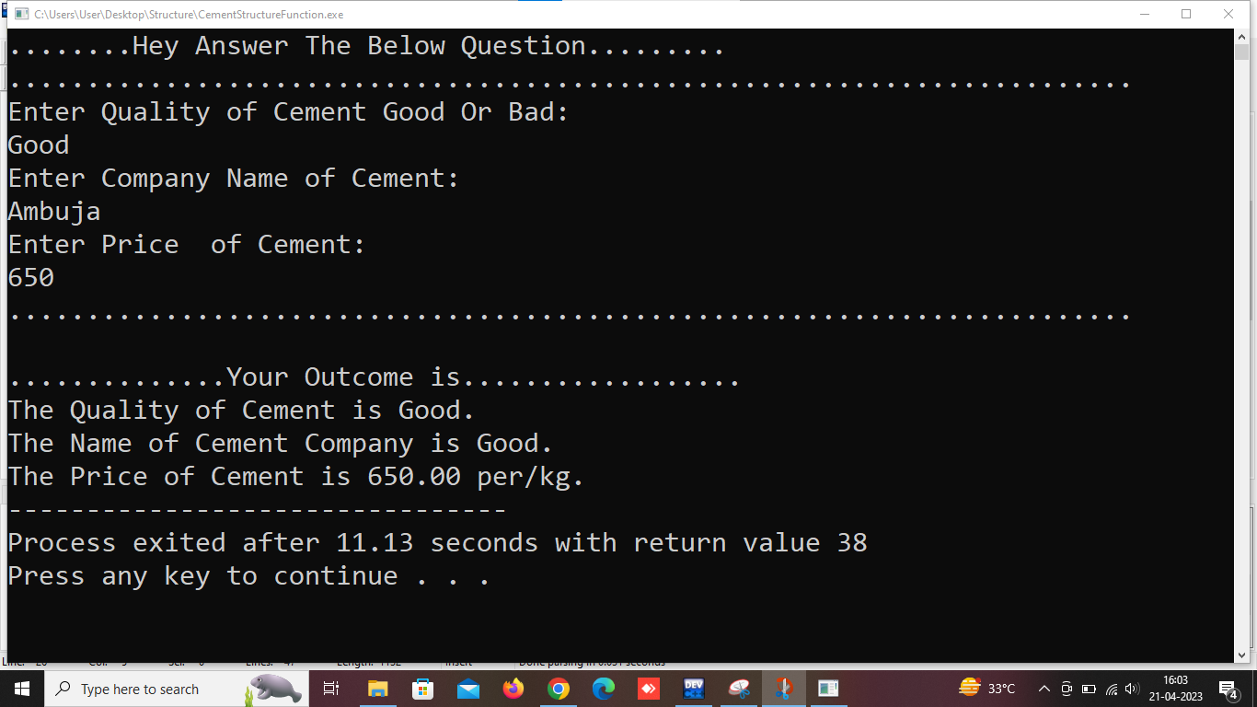}

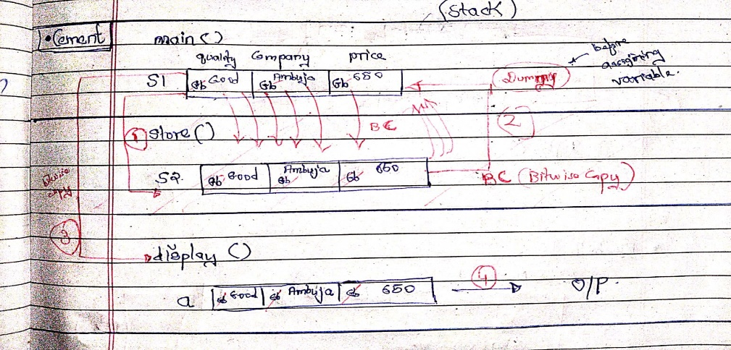

<………………………………………………………………………………………………………………………………………………………..>

**2.Steel.**

.

#include<stdio.h>

#include<string.h>

struct Steel

{

char quality[50];

char company[50];

float price;

};

struct Steel store(struct Steel );

void display(struct Steel s2);

void main()

{

struct Steel s1;

s1=store(s1);

display(s1);

}

struct Steel store(struct Steel s2)

{

puts("........Hey Answer The Below Question.........");

puts("........................................................................");

puts("Enter Quality of Steel Good Or Bad:");

scanf("%s",&s2.quality);

puts("Enter Company Name of Steel:");

scanf("%s",&s2.company);

puts("Enter Price of Steel:");

scanf("%f",&s2.price);

return s2;

}

void display(struct Steel a)

{

puts("........................................................................");

puts("\n..............Your Outcome is..................");

printf("The Quality of Steel is %s.",a.quality);

printf("\nThe Name of Steel Company is %s.",a.quality);

printf("\nThe Price of Steel is %.2f per/kg.",a.price);

}

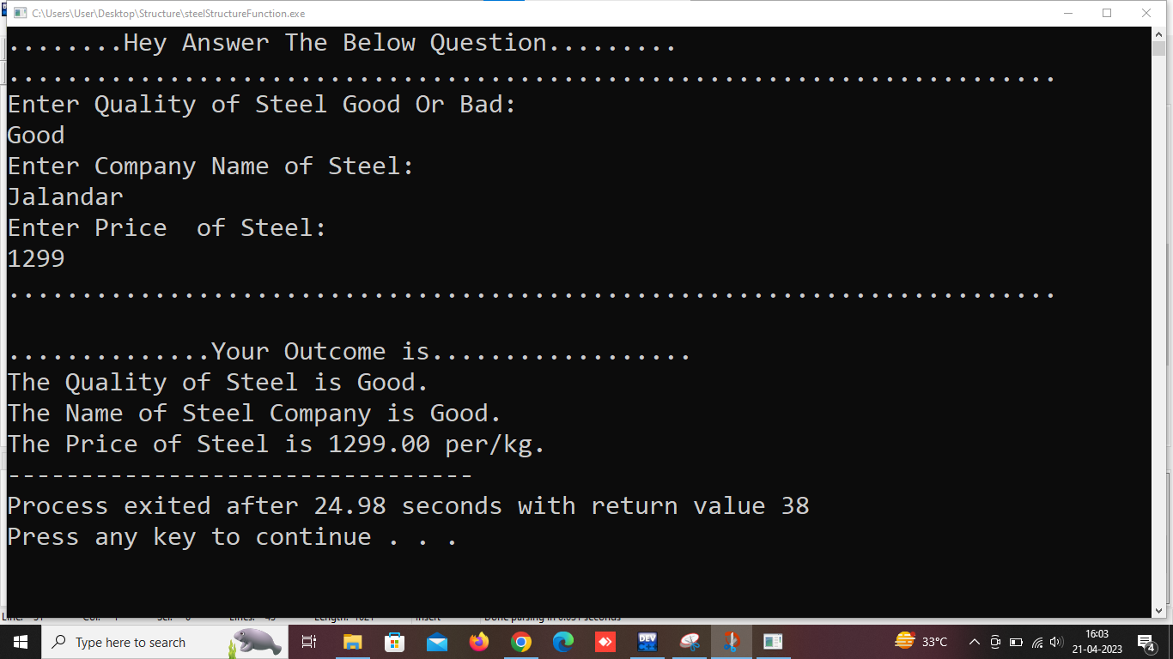

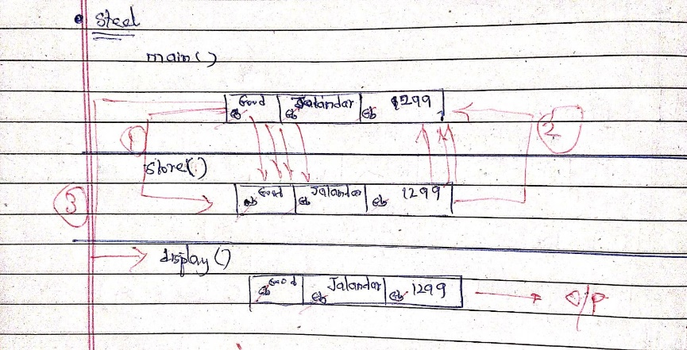

<………………………………………………………………………………………………………………………………………………………..>

**3.Watch.**

#include<stdio.h>

#include<string.h>

struct Watch

{

char quality[50];

char company[50];

float price;

};

struct Watch store(struct Watch );

void display(struct Watch s2);

void main()

{

struct Watch s1;

s1=store(s1);

display(s1);

}

struct Watch store(struct Watch s2)

{

puts("........Hey Answer The Below Question.........");

puts("........................................................................");

puts("Enter Quality of Watch Good Or Bad:");

scanf("%s",&s2.quality);

puts("Enter Company Name of Watch:");

scanf("%s",&s2.company);

puts("Enter Price of Watch:");

scanf("%f",&s2.price);

return s2;

}

void display(struct Watch a)

{

puts("........................................................................");

puts("\n..............Your Outcome is..................");

printf("The Quality of Watch is %s.",a.quality);

printf("\nThe Name of Watch Company is %s.",a.quality);

printf("\nThe Price of Watch is %.2f Only/-.",a.price);

}

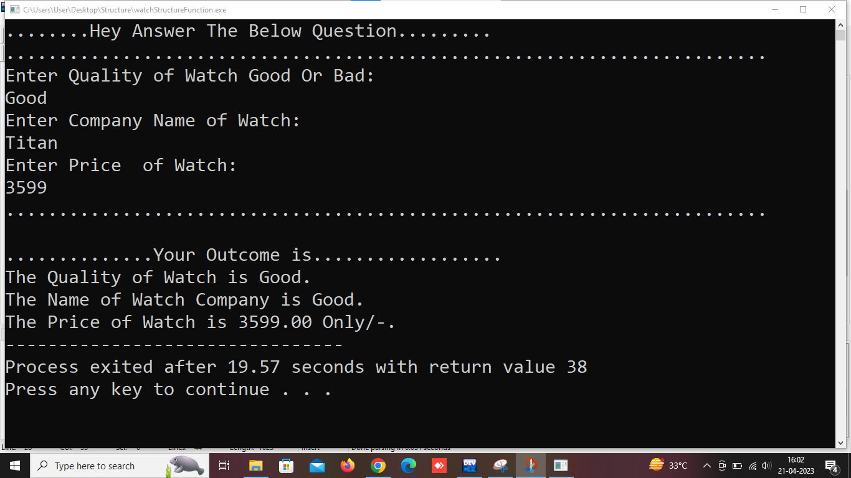

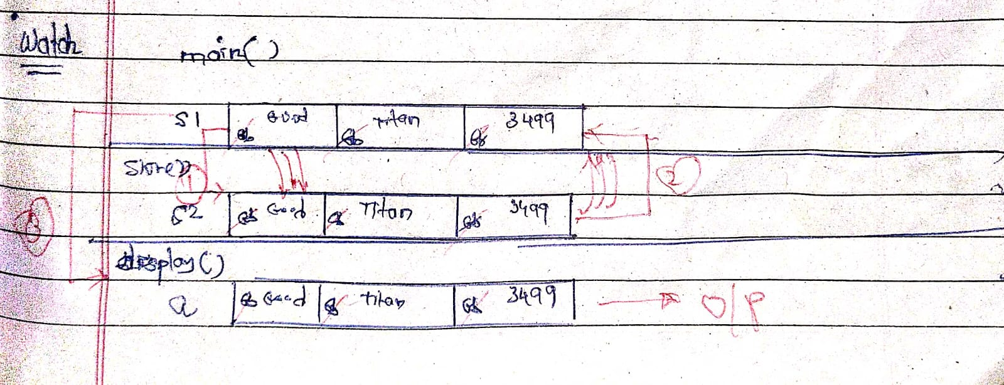

<………………………………………………………………………………………………………………………………………………………..>

**4.Eyeglass.**

#include<stdio.h>

#include<string.h>

struct Eyeglass

{

char quality[50];

char company[50];

float price;

};

struct Eyeglass store(struct Eyeglass );

void display(struct Eyeglass s2);

void main()

{

struct Eyeglass s1;

s1=store(s1);

display(s1);

}

struct Eyeglass store(struct Eyeglass s2)

{

puts("........Hey Answer The Below Question.........");

puts("........................................................................");

puts("Enter Quality of Eyeglass Good Or Bad:");

scanf("%s",&s2.quality);

puts("Enter Company Name of Eyeglass:");

scanf("%s",&s2.company);

puts("Enter Price of Eyeglass:");

scanf("%f",&s2.price);

return s2;

}

void display(struct Eyeglass a)

{

puts("........................................................................");

puts("\n..............Your Outcome is..................");

printf("The Quality of Eyeglass is %s.",a.quality);

printf("\nThe Name of Eyeglass Company is %s.",a.quality);

printf("\nThe Price of Eyeglass is %.2f Only/-.",a.price);

}

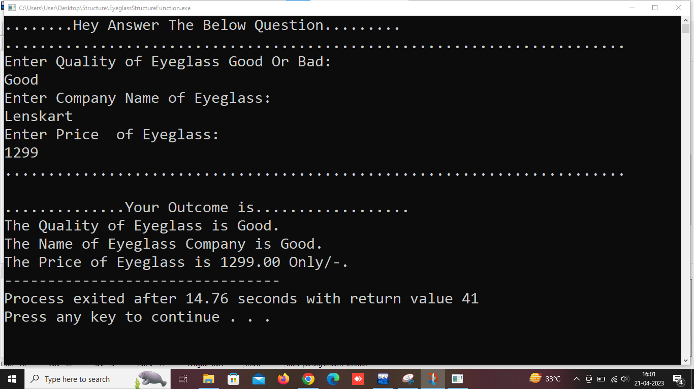

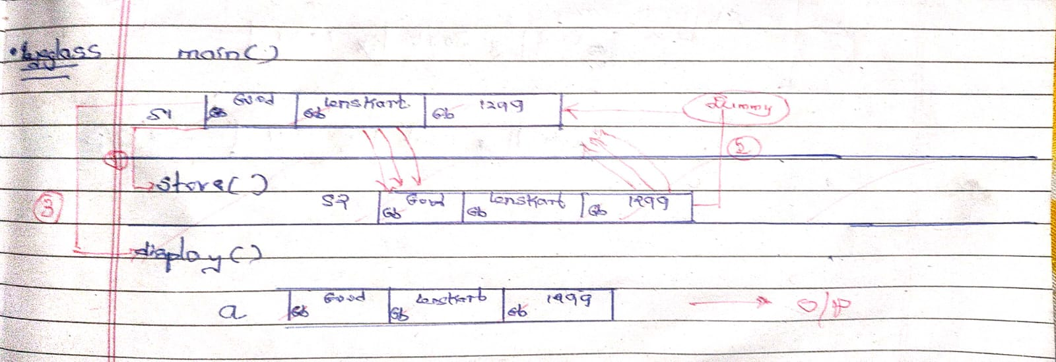

<………………………………………………………………………………………………………………………………………………………..>

**5.Bluetooth Device.**

#include<stdio.h>

#include<string.h>

struct Bluetooth_device

{

char quality[50];

char company[50];

float price;

};

struct Bluetooth_device store(struct Bluetooth_device );

void display(struct Bluetooth_device s2);

void main()

{

struct Bluetooth_device s1;

s1=store(s1);

display(s1);

}

struct Bluetooth_device store(struct Bluetooth_device s2)

{

puts("........Hey Answer The Below Question.........");

puts("........................................................................");

puts("Enter Quality of Bluetooth_device Good Or Bad:");

scanf("%s",&s2.quality);

puts("Enter Company Name of Bluetooth_device:");

scanf("%s",&s2.company);

puts("Enter Price of Bluetooth_device:");

scanf("%f",&s2.price);

return s2;

}

void display(struct Bluetooth_device a)

{

puts("........................................................................");

puts("\n..............Your Outcome is..................");

printf("The Quality of Bluetooth_device is %s.",a.quality);

printf("\nThe Name of Bluetooth_device Company is %s.",a.quality);

printf("\nThe Price of Bluetooth_device is %.2f Only/-.",a.price);

}

